
PHYSICS notes

UNIT 3 Gravitation and Electromagnetism
Gravitation
- Movement of free-falling bodies in Earth’s gravitational field is predictable
- Projectile motion can be analysed quantitatively by treating the horizontal and vertical components of the motion independently
- EQUATIONS
$v=\frac{s}{t}$ $a=\frac{v-u}{t}$ $v=u+at$ $s=ut+\frac{1}{2}at^{2}$ $v^{2}=u^{2}+2as$ $E_{k}=\frac{1}{2}mv^{2}$

PROJECTILES
A projectile is any object which, once projected, continues its motion by its own inertia and is influenced only by the downward force of gravity
Air resistance opposes motion both vertically and horizontally. It is tangential to the flight curve directly opposing the instantaneous velocity v_{i}
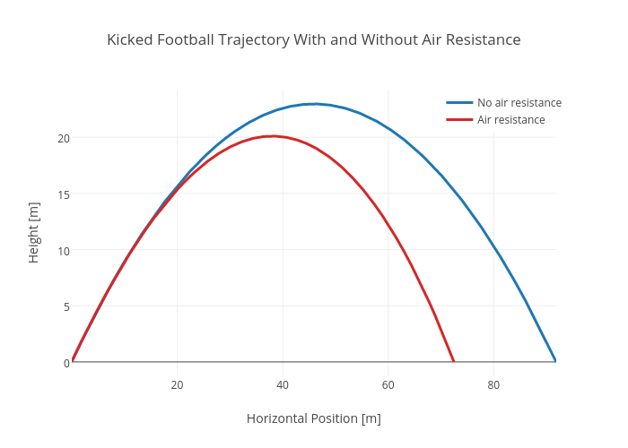

Without air resistance
- Path is parabolic
With air resistance
- Doesn’t go as high
- Doesn’t go as far
- Not symmetrical
- Peaks earlier
When a projectile has a launch angle other than 0º, its launch velocity v_{o} must be broken up into its rectangular components to perform calculations. It is better to treat the launch velocity as two separate velocities.

3 types of projectiles
- Launch angle = 0º so s = down
- Launch angle ≠ 0º so s = 0m
- Launch angle ≠ 0º so s = up or down
Trigonometry Identity to proof
Horizontal
$$R=v_{o}Cosθ × t$$
$$t=\frac{R}{v_{o}Cosθ}$$

V_{o} V_{o}Sin θ
Vertical
$$s=ut+\frac{1}{2}at^{2}$$
$$0=u-4.9t$$
$$t=\frac{v_{o}Sinθ}{4.9}=\frac{R}{v_{o}Cosθ}$$
θ = 45º
v_{o}Cos θ
$$R=\frac{v_{o}^{2}Sinθ Cosθ}{4.9}$$
$$R=\frac{v_{o}^{2}2Sinθ Cosθ}{9.8}$$
$$R=\frac{v_{o}^{2}Sin2θ}{9.8}$$
$$R α Sin 2 θ$$
$$2Sin θ= θ={90}^{o}$$
$$2θ={90}^{o}$$
$$θ={45}^{o}(proof)$$

UNIVERSAL PROJECTILE EQUATION FOR TRIG IDENTITY
$$s=R Tanθ-\frac{4.9R^{2}}{v_{o}^{2}Cos^{2}θ}$$

Points to remember:
- A projectile with non-zero launch angle will be at a certain altitude at two separate times t₁ and t_{2,} once on the way up and once on the way down, unless that time is at the apex of its flight. Therefore, solution for t is quadratic $x=\frac{-b±\sqrt{b^{2}-4ac}}{2a}$ $ax^{2}+bx+c=0$
- The final velocity of a projectile is the vector addition of its vertical and horizontal velocities. It has magnitude and direction.
- For projectiles with s_{v} = 0 there are two angles which produce the same range, 45º - θ and 45º + θ
- Maximum range for projectiles with s_{v} = 0 is achieved when launch angle = 45º
- When considering a situation with wind, add or subtract the wind velocity from the horizontal component of the launch velocity to determine the net forward velocity.
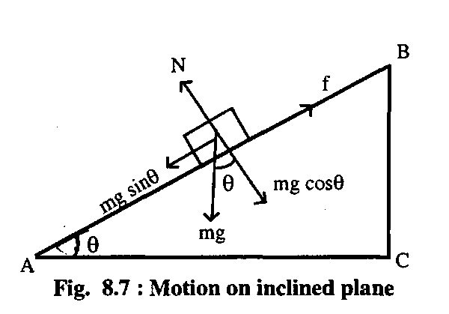
The vector nature of the gravitational force can be used to analyse motion on inclined planes by considering the components of the gravitational force (weight) parallel and perpendicular to the plane.

CIRCULAR MOTION
When an object experiences a net force of constant magnitude perpendicular to its velocity, it will undergo uniform circular motion, including circular motion on a horizontal plane and around a banked track and vertical circular motion.
$v=\frac{2πr}{T}$ $a_{c}=\frac{v^{2}}{r}$ $F_{r}=ma_{c}=\frac{mv^{2}}{r}$

When an object is going around in a circle in uniform motion (constant speed), the net force acting on it is towards the centre of the circle and is called the centripetal force F_{c.} This force does not exist as a separate entity. It is the resultant vector addition of all the forces acting on the object.
QUESTIONS TO CONSIDER WHEN SOLVING CIRCULAR MOTION:
- Is it going around in a circle?
- Where is the centre of that circle?
- What are the forces acting on it?
- How do those forces add up vectorially to the F_{c}?
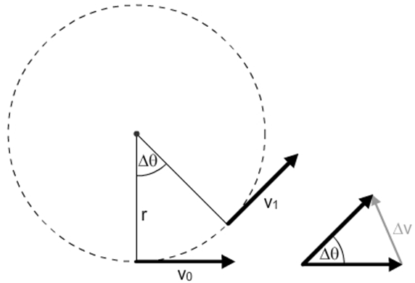

Applies relationship ${ F}_{g}=G\frac{m_{1}m_{2}}{r^{2}}$
Objects with mass produce a gravitational field in the space that surrounds them; field theory attributes the gravitational force on an object to the presence of a gravitational field $F_{w}=mg$
Gravitational field strength is defined as the net force per unit mass at a particular point in the field.
Applies relationship $g=\frac{F_{g}}{m}=G\frac{M}{r^{2}}$
SATELLITES
Only force acting on a satellite is the gravitational force ie. $F_{c}=\frac{mMG}{d^{2}}$
There are many other variables which can come into play with questions about satellites eg. Period, frequency of orbit, length of day/year. These will all be used to calculate velocity.
Newton’s Law of Universal Gravitation is used to explain Kepler’s Laws of Planetary Motion and to describe the motion of planets and other satellites, modelled as uniform circular motion.
Applies relationship $\frac{T^{2}}{r^{3}}=\frac{4π^{2}}{GM}$
Deriving Kepler’s Law
$$F_{c}= F_{g}$$
$where F_{C}=\frac{mv^{2}}{r}$ and $F_{g}=\frac{mMG}{r^{2}}$
$$\frac{mv^{2}}{r}=\frac{mMG}{r^{2}}$$
where $v=\frac{2πr}{T}$ therefore substitute equation in place of v
$$\frac{4π^{2}r^{2}}{T^{2}}=\frac{MG}{r}$$
$$T^{2}=\frac{4π^{2}}{MG}r^{3}$$

BANKED TRACKS
Disregarding friction, there are two forces, mg and N which add up to F_{c}. The following equation can be derived from this $\tan{θ=\frac{v^{2}}{rg}}$
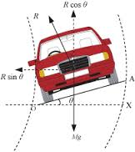

When a mass moves or is moved from one point to another in a gravitational field and its potential energy changes, work is done on the mass by the field
Applies relationships $E_{p}=mgΔh$ $W=Fs$ $W= ΔE$ $E_{k}=\frac{1}{2}mv^{2}$
There are many different situations where an object completes a vertical circle. If it is allowed to free fall, it is NOT uniform circular motion EXCEPT at the top and bottom of the swing. If the speed is kept constant there will need to be another force at work eg. Loop the loop
In every situation, problem solving technique is the same.
- Establish uniform circular motion
- Draw a free body diagram of the forces acting on the body
- Add those forces to determine the resultant F_{c}
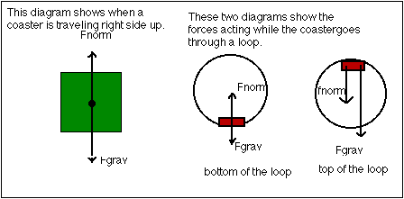
Rollercoaster; it is freewheeling and running underneath the track.
At the top of the circle $F_{c}=mg+R$
At the bottom of the circle $F_{C}=R-mg$
Weightlessness occurs when R = 0 or when $\frac{mv^{2}}{r}=mg$. This is the minimum velocity that will keep the body in circular motion. A car going over a hump in the road has a different free body diagram
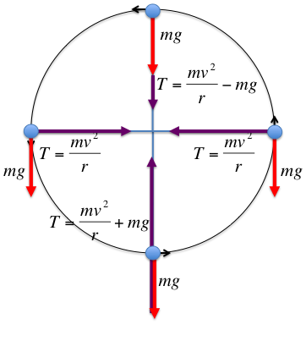
Conical pendulum; the two forces acting on the object travelling in a horizontal circle are mg and T. These add up to the centripetal force.
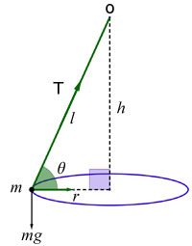
$Cosθ=\frac{mg}{T}$ where $T=\frac{mg}{Cosθ}$

Centrifugal force; there is no such force. It is an effect or sensation of being thrown outwards by a spinning or turning object. You will be thrown off if the F_{c} is not sufficient to maintain circular motion. You will maintain your instantaneous velocity which is ALWAYS perpendicular to the radius of the circle in which you are travelling
Points to remember
- All circular motion problems involve resolution of forces. This can be one force (satellites), two co-linear forces (vertical motion), two co-planar forces (banked tracks) or where the F_{c} is a component of one or two forces (conical pendulums, banking planes).
- The strength of a gravitational field is defined as N/kg or ms⁻². The formula is given by
$g=\frac{GM}{r^{2}}$. When comparing the strength of a field at two points at different distances from an object use the inverse square law $\frac{T^{2}}{r^{3}}=\frac{4π^{2}}{GM }$ or $\frac{g_{1}}{g_{2}}=\frac{r_{2}^{2}}{r_{1}^{2}}$
- An object’s weight is less at the equator that at the poles because part of the gravitational force is required to maintain circular motion
- Satellites are launched from close to the equator in the direction of the Earth’s rotation. This is so the kinetic energy can be used to conserve fuel.
- Geostationary satellites orbit above the equator. This is the only way the Earth’s centre, the spot on the Earth’s surface and the satellite can be perpetually in line. All satellites must orbit the centre of mass of the Earth.
- A g-force is an acceleration equal to 9.8 m s⁻². A g-force of 6 gs is equal to 6 x 9.8 m s⁻² or 58.8 m s⁻². Always remember to include the weight force (mg) in any calculation.

STABILITY
Refers to low centre of mass and width of base, the lower the centre of mass and the wider the base, the more stable a body is.

F
Δh

mg is providing restorative moment
mg T mg
stability is determined by how much energy is required to get the centre of mass outside the base or raise it to its apex $E=W=mgΔh$
types of stability

stable unstable neutral
STRUCTURES
When an object experiences a net force at a distance from a pivot and at an angle to the lever arm, it will experience a torque or moment about that point.
A moment is defined as a force multiplied by the perpendicular distance of the line of action of that force to the pivot. Moments are taken from a pivot to eliminate as many forces as possible.
Applies relationship $τ=rFSinθ$
For a rigid body to be in equilibrium, the sum of the forces and the sum of the moments must be zero
Applies relationship $ƩF=0$ $τ=rFSinθ$ $Ʃτ=0$
Referring to situations where a number of forces are acting on a body but the body is not moving, Newton’s first law states that there is no net force acting on it. For this to occur, 3 conditions must be satisfied;
- $Ʃv_{f}=0$
- $ƩH_{f}=0$
- $Ʃcw moments= Ʃacw moments$
A turning moment is defined as a force x radius. The radius is the perpendicular distance from the line of action of the force to the pivot. Essentially, these three conditions say all forces downwards equal all upwards forces, forces pulling to the left equal those pulling to the right and any force trying to rotate the body one way are matched by forces trying to rotate it the other way.
The turning moment of the force F is equal to F x rCosθ. The maximum turning moment is when the lever is at an angle of 0º. The lever arm length is NOT the distance you should use to calculate torque. For a body in equilibrium, moments can be taken about any point and the third condition still holds. In most instances, it is wise to take moments around the point where some forces act thereby eliminating them from the calculation.
Torque units are Nm NOT N m⁻¹ or N.
Situations of torque
- Balance beams
- String problems
- Drawbridges (anything that is fixed to a wall by a hinge and a diagonal tie. There is a reaction force of the wall on the beam which has horizontal and vertical components. MUST provide an ANGLE and MAGNITUDE)
- Ladders (many forces act on a ladder, the reaction force of the ground on the ladder has vertical and horizontal components. The wall MUST be smooth which means the VERTICAL COMPONENT OF REACTION FORCE IS ZERO)

Drawbridge R

mg
T T
d₃
R
θ
(mg_{beam}xd₁) + (mg_{mass}xd₂)
d₁ = T x d₃
R of wall on beam
Solve R
mg_{beam} Solve R_{v} = 0 and R_{H} = 0
Use Pythagoras to solve

d₂ mg_{mass}
R R_{v} = mg – T_{v}
$c^{2}=a^{2}+b^{2} pythagoras^{'}theorem$
R_{H} = mg – T_{v}

Points to remember
- Net reaction forces have magnitude and direction
- Torque = Nm
- All the mass of an object acts through its centre of mass
- Normal force acts perpendicular to forces
- Negative answer doesn’t mean it’s wrong

GRAPHING PROBLEMS
- Experimental data
- NOT theoretical value
- Linearize data and calculate values from slope
- Isolate dependant variable
- Adjust data to produce a straight line through substitution
- Isolate expression from gradient
- NEVER go through origin unless there is data at (0,0)
ELECTROMAGNETISM
Moving charged particles have a magnetic field around them.
Moving charged particles in magnetic fields experience force when not parallel to the field $F=BVq$
Right hand rule for positive
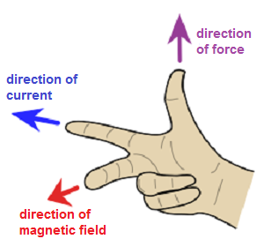

Left hand rule for negative
Current carrying coils have a magnetic field around them
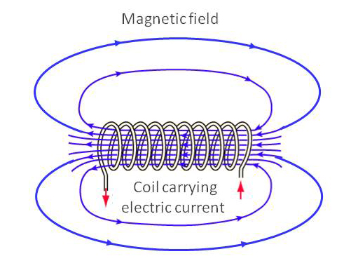
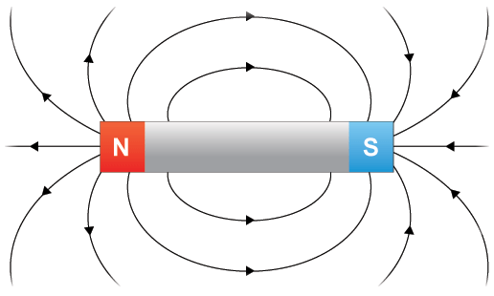
Drawing magnetic fields
3 things must be shown
- The direction
- The shape
- The relative density

The field lines flow from north to south and are more dense at the poles. They must NEVER CROSS.

The Earth’s magnetic field
The Earth’s magnetic field is parallel to the ground at the equator and almost perpendicular at the poles. Everywhere else it is at an angle (dip) to the surface. The geographic North pole is actually the magnetic South pole.

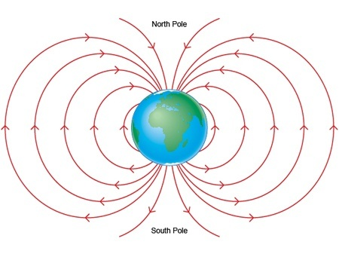
S
N

Magnetic Flux Density B is measured in Newton-metres per ampere Nm A⁻¹ also called Teslas T. The magnetic field can be visualised as magnetic field lines. The field strength corresponds to the density of the field lines. The total number of magnetic field lines penetrating an area is called the magnetic flux. The unit of the magnetic flux Φ is the tesla metre squared Tm² also called Webers Wb. $B=\frac{Φ}{A}$
The direction of conventional current is that in which the flow of positive charge takes place, while the electron flow is the opposite direction.
Current carrying wires are surrounded by magnetic fields, these fields are utilised in solenoids and electromagnets.
The strength of the magnetic field produced by a current is a measure of the magnetic flux density.
Applies relationship $B=\frac{μ_{0}}{2π} ×\frac{I}{r}$
Moving electrons also have a magnetic field around them which is referred to as conventional current which is the flow of positive charge. To find the direction, use RHR, for electrons use LHR.
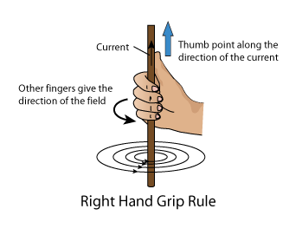
The magnitude of the magnetic field changes at the strength decreases as you move away from the wire. $B=\frac{μ_{0}}{2π} ×\frac{I}{r}$
I is the current (A), r is the perpendicular distance measured from the centre of the wire (m) and μ₀ is a constant known as the permeability of free-space = 1.26 x 10⁻⁶ N A⁻²
$strength of field=B=\frac{μ_{0}}{2π} ×\frac{I}{r}$ where μ_{o} = 4π x 10⁻⁷ N A⁻² = 1.26 x 10⁻⁶ N A⁻²
B is inversely proportional to r
B

r

SOLENOIDS
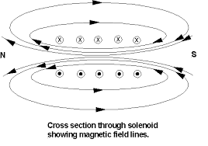
A solenoid is a wire looped around a tubular body. If a current is run through it, the magnetic fields around each loop combine to form an overall field similar to a bar magnet. If the current flows clockwise it is the South pole and if the current flows anticlockwise it is the North pole. If a soft iron core is placed inside the coil, it becomes magnetised and be attracted to magnetic material outside the solenoid. This is an electromagnet.

MOTORS
Magnets, magnetic materials, moving charges and current carrying wires experience a force in a magnetic field when they cut flux lines; this force is utilised in DC electric motors and particle accelerators.
Applies relationships $F=qvB where v ⊥B$ $F=IlB where l ⊥B$
The force due to a current in a magnetic field in a DC electric motor produces a torque on the coil in the motor
Applies relationship $τ=r_{⊥}F$
If we turn a wire into a coil and place it in an external magnetic field, a force will be exerted on each side of the coil in opposite directions. This makes the coil spin and is the basis of an electric motor.
$$F=BIl$$
Motor: rotates due to a force on a current-carrying wire in a magnetic field $F=BIl$ which creates a torque $τ=Fr$; motion produced by electricity
Where r = perpendicular width of coil. The total torque on a motor is given by: $τ_{T}=2NBIlr or τ_{t}=NBIA$
Where n = the number of coils in the coil (turns). To reverse the current every half turn and hence maintain rotation, a split ring commutator is used. Split ring commutator reverses the connections of the coil to the external circuit each time the coil current reverses.
The output of a motor can be increased by increasing any of the values in the equation.

GENERATORS
An induced emf is produced by the relative motion of a straight conductor in a magnetic field when the conductor cuts flux lines
Applies relationship $induced emf=lvB where v ⊥B$
Magnetic flux is defined in terms of magnetic flux density and area
Applies relationship $Φ=BA_{⊥}$
A changing magnetic flux induces a potential difference; this process of electromagnetic induction is used in step-up and step-down transformers, DC and AC generators.
Applies relationships $induced emf= -N\frac{\left(Φ_{2}-Φ_{1}\right)}{t}= -N\frac{ΔΦ}{t}= -N\frac{Δ(BA_{⊥})}{t}$
AC generator $emf_{max}=-2NlvB= -2πNBA_{⊥}f$ $emf_{rms}=\frac{emf_{max}}{√2}$
Conservation of energy expressed as Lenz’s Law of electromagnetic induction is used to determine the direction of induced current.
The induced emf in a conductor of length l when it is moved at a velocity v within a magnetic field B is given by $ε= -Bvl$
The direction of the induced emf is such that it creates a current that opposes the motion which created it. Stated as Lenz’s Law.
Generators: operates by physically rotating a coil of wire within a magnetic field; electricity produced by motion
If we run a current through a wire in a magnetic field, we get movement. If we move a wire through a magnetic field, we get current. This is a generator. We induce an emf which in turn will produce a current if connected to an external circuit. The emf induced is given by Faraday’s Law.
$emf=-N\frac{ΔBA}{Δt}$
For a conductor moving in a magnetic field, the emf induced is given by $emf=Bvl$ where v is the velocity.
Faraday’s Law states that the rate of change of the flux Φ in a rotating coil results in an emf ε given by $ε=\frac{-nΔΦ}{Δt}$ where n is the number of turns in the coil and the emf is 90º out of phase with the flux.
When cutting the Earth’s magnetic field, we are usually only cutting one component of it due to the angle of dip. Flying parallel to the Earth’s surface, we are cutting the perpendicular or vertical component or BSinθ

TRANFORMERS
EQUATIONS $\frac{V_{p}}{V_{s}}=\frac{N_{p}}{N_{s}}=\frac{I_{s}}{I_{p}}$ $I_{p}V_{p}=I_{s}V_{s}$ $P=VI=I^{2}R=\frac{V^{2}}{R}$
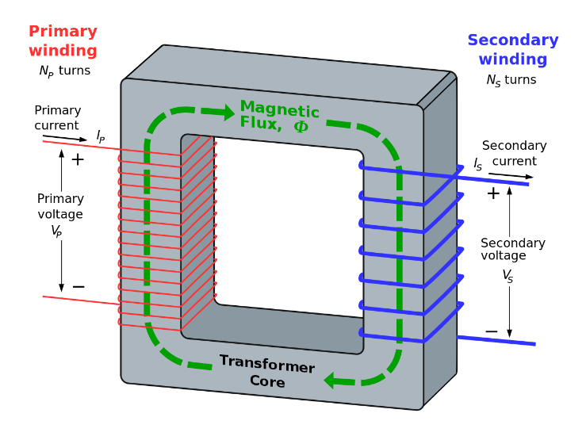
Transformer: is an AC-operated device which allows voltages to be increased and decreased. The associated current must change in the same ratio, but inversely, as the input power must EQUAL the output power in a 100% efficient transformer. The voltage V and current I ratios are determined by the turns of wire in the primary n_{p} and secondary n_{s} coils given by equations.

To transmit power over long distances will lose a lot of energy through heating the wires. If large currents are used $P=I^{2}R$. As $P=IV$, we can transmit the same power at high voltages and low currents to minimise power loss. This requires the emf generated at the source to be stepped up. This is done in the use of transformers. The changing magnetic field in the primary coil induces a magnetic field in the second in direct proportion to the ratio of number of turns in the secondary to the primary coils. To produce a constantly changing magnetic field, alternating current AC must be used.

Minimising heat losses in transformers
Dividing the iron core into thin insulated laminators minimises eddy current loss.
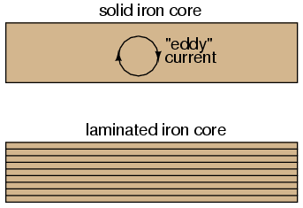
Laminated cores like the one shown are standard in almost all low-frequency transformers. Eddy current losses increase with frequency, so transformers designed to run on high-frequency power must use thinner laminations to keep the losses down to a minimum.
Eddy Currents are induced currents caused by magnetic fields. They can create electromagnetic and heat problems within transformer cores. To reduce eddy currents, these cores are constructed of sheets or laminations rather than as a solid block.
Another ‘core loss’ is that of magnetic hysteresis. All ferromagnetic materials tend to retain some degree of magnetization after exposure to an external magnetic field. This tendency to stay magnetized is called ‘hysteresis’, and it takes a certain amount of energy to overcome this opposition to change every time the magnetic field produced by the primary winding changes polarity. This type of loss can be reduced by using good core material selection.

Points to remember
- Lenz’s Law states that the electromotive force emf induced in a conductor moving perpendicular to a magnetic field tends to oppose that motion.
- Motors will induce a back emf as they rotate due to Lenz’s Law
- The average output of a generator is the RMS voltage or $\frac{V_{max}}{√2}$
- RMS stands for root mean square and allows us to calculate the equivalent DC power from an AC source, given by $P=V_{RMS}I_{RMS}$
- $V_{RMS}=\frac{V_{peak}}{√2}$ $I_{peak}=\frac{V_{peak}}{√2}$ $I_{RMS}=\frac{V_{RMS}}{R}$
- $efficiency=\frac{out}{in}×100$

ELECTRIC FIELDS
Electrostatically charged objects exert a force upon one another; the magnitude of this force can be calculated using Coulomb’s Law
Applies relationship $F=\frac{1}{4πε_{0}}\frac{q_{1}q_{2}}{r^{2}}$
Point charges and charged objects produce an electric field in the space that surrounds them; field theory attributes the electrostatic force on s point charge or charged body to the presence of an electric field.
A positively charged body placed in an electric field will experience a force in the direction of the field; the strength of the electric field is defined as the force per unit charge.
Applies relationships $E=\frac{F}{q}$ $E=\frac{V}{m}$
When a charged body moves or is moved from one point to another in an electric field and its potential energy changes, work is done on the charge by the field.
Applies relationship $V=\frac{W}{q}$ where $W=Vq=\frac{mv^{2}}{2}$ so $v=\frac{\sqrt{2Vq}}{m}$ so $v=\sqrt{2gh}$
- A charged particle in an electric field will experience a force equal to E_{q} so ma = E_{q}
- We can IGNORE GRAVITY if mg is much smaller than E_{q}
- If NOT, add mg vectorially to the calculation
An electric field is a vector quantity with the direction defined by the force experienced by a positive charge point.
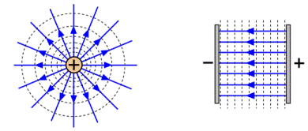

UNIT 4 Revolutions in Modern Physics
Wave particle duality and the Quantum Theory
- Light exhibits many wave properties, it cannot only be modelled as a mechanical wave because it can travel through a vacuum
- A wave model explains a wide range of light-related phenomena, including reflection, refraction, dispersion, diffraction and interference; a transverse wave model is required to explain polarisation
- Electromagnetic waves are transverse waves made up of mutually perpendicular, oscillating electric and magnetic fields
- Oscillating charges produce electromagnetic waves of the same frequency as the oscillation; electromagnetic waves cause charges to oscillate at the frequency of the waves
- Atomic phenomena and the interaction of light with matter indicate that states of matter and energy are quantised into discrete values
- On the atomic level, electromagnetic radiation is emitted or absorbed in discrete packets called photons. The energy of a photon is proportional to its frequency. The constant of proportionality, Planck’s constant, can be determined experimentally using the photelectric effect and the threshold voltage of the coloured LEDs
Applies relationships $c=fλ$ $E=hf=\frac{hc}{λ}$ $E_{k}=hf-W$ $de Brogile λ=\frac{h}{p}$
- A wide range of phenomena, including black body radiation and the photoelectric effect are explained using the concept of light quanta
- Atoms of an element emit and absorb specific wavelengths of light that are unique to that element; this is the basis of spectral analysis
Applies relationships $ΔE=hf$ $E_{2}-E_{1}=hf$
- The Bohr model of the hydrogen atom integrates light quanta and atomic energy states to explain the specific wavelengths in the hydrogen spectrum and in the spectra of other simple atoms; the Bohr model enables line spectra to be correlated with atomic-level diagrams
- On the atomic level, energy and matter exhibit the characteristics of both waves and particles. Young’s double slit experiment is explained with a wave model but produces the same interference and diffraction patterns when one photon at a time or one electron at a time are passed through the slits.
When an electron slows down or loses energy, it gives off a photon with the equivalent energy which is given by $E=hf$ , where f is the frequency and h is Planck’s constant = 6.63 x 10⁻³⁴Js. Conversely, electrons can absorb photons and jump to higher energy level in the atom. If the incoming photon has enough energy, electrons can be liberated or ionised from the atom with the balance of the photon’s original energy.
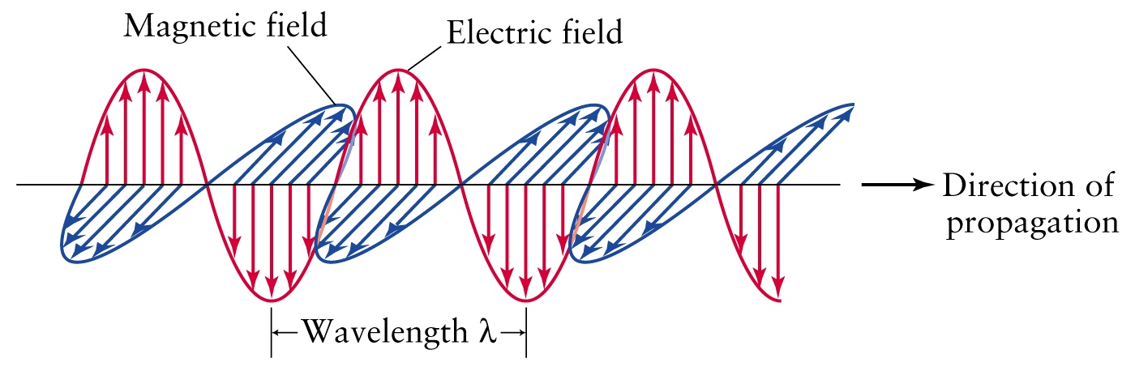
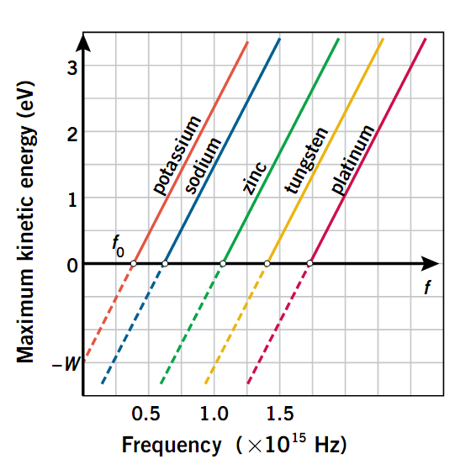
The graph shows the energy of an electron given off when light of a certain frequency hits different metals. Each metal has a different threshold frequency which is required to ionise an electron, but the slope of each graph is the SAME; this is Planck’s Constant. This effect shows the particle nature of light where an increase in intensity DOES NOT increase the energy of liberated electrons. It increases the number of electrons liberated. Increasing the intensity of a given wavelength of light increases the number of photons, not their individual energy.

The diagram shows electrons in an atom falling down to lower energy levels. Each combination of levels will probably have a different energy difference and therefore produce a photon of specific wavelength. When an atom is excited electrons jump to a higher energy level leaving a hole for others to fall back into. This produces a spectrum of wavelengths unique to that element. This appears as coloured lines on a black background. Emission spectrum.
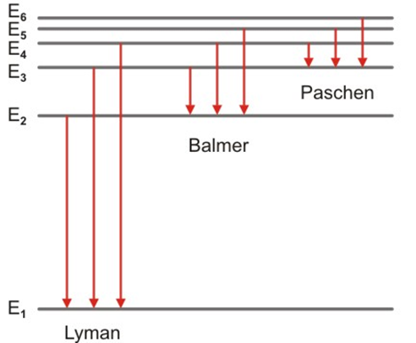
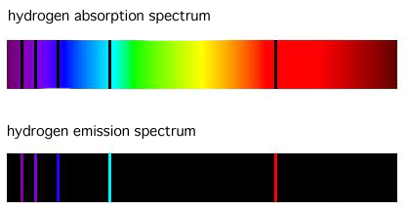
If white light from a source is shone through a gas, the wavelengths corresponding to emission spectrum for that element are absorbed then re-emitted in all directions hence diminishing the apparent intensity of those lines. The spectrum in the visible range of wavelengths will appear as dark lines on a rainbow background. Absorption Spectrum. A gaseous compound will give off a band spectrum and a solid body will give off the full spectrum.
CALCULATIONS
- An atom with n levels will produce $\frac{n\left(n-1\right)}{2}$ spectral lines
- $E=hf$ only works with Joules. The energy levels are usually given in eV (electron volts)
1 Volt = 1 J C⁻¹ where q_{electron} = 1.6 x 10⁻¹⁹ C where 1 eV = 1.6 x 10⁻¹⁹ J
- $c=λf$ and $f=\frac{E}{h}$ so $λ=\frac{ch}{E}$ so when converting energy difference in eV to λ in m use
$\frac{ch}{1.6×{10}^{-19}}=\frac{3×{10}^{8}×6.63×{10}^{-34}}{1.6×{10}^{-19}}=1.243×{10}^{-6}$ so simply divide 1.243x10⁻⁶ by the energy difference in eV to get the wavelength.

- If an atom is bombarded with photons, only those frequencies of photon which correspond to an energy level difference will be absorbed
- If an atom is bombarded with electrons, the incoming electron can be bounced off with no loss of energy, give some of its energy to promote another electron or give all its energy to ionising an electron.
- Energy levels are often expressed as how much energy is required to ionise an electron from that level. They are therefore expressed as negative energies.
Stopping voltage: emission of electrons is caused by fixed frequency of the incident light hitting the metal. By applying a negative voltage through the metal the emission of electrons can be reduced or stopped given by equation $E_{k}=\frac{1}{2}mv^{2}=V × q$
The photoelectric effect is an example of a photon, or light, acting as a particle. An individual photon can ‘collide’ with an individual electron and donate all its energy.
LIGHT AS A WAVE
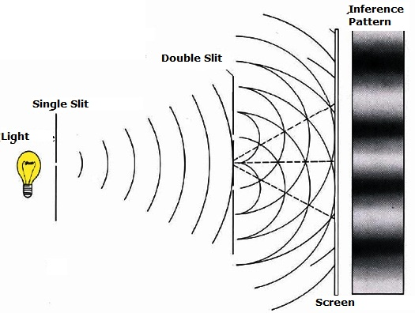
If light was only a particle, shining light through two slits on a screen, would produce two bright lights. It doesn’t. light also behaves like a wave when it diffracts, refracts and undergoes interference. This is called the dual nature of light.
A wide range of phenomena, including black body radiation and the photoelectric effect, are explained using the concept of light quanta.
Black body radiation absorbs ALL electromagnetic radiation that strikes it. For it to maintain thermal equilibrium it must emit radiation at the same rate as it absorbs it. All objects emit thermal radiation as long as their temperature is above absolute zero. As the temperature of a black body increases the total amount of light emitted per second (intensity) increases and the wavelength of the spectrum’s peak shifts to bluer colours. This means as the object is heated to a high temperature, a block body will begin to glow with thermal radiation at peak frequencies.
Wien’s Law: as black body heats, maximum wavelength emission shortens and energy radiated increases at all wavelengths $λ_{max}=\frac{b}{T}$ where b = Wein’s constant = 2.898 x 10⁻³ m K and T = absolute temperature (K = ºc + 273)
Stephen-Boltzmann’s Law: the total power radiated from a black body is given by the equation $P_{blackbody}=σAT^{4}$ where σ = Stefan-Boltzmann’s constant = 5.699 x 10⁻⁸ W m⁻² K⁻⁴, P_{blackbody} = power (W) and A = surface area emitting radiation (m²)
Planck’s Quanta: electromagnetic radiation can not be radiated or absorbed in any arbitrary amount, so Wien’s Law needed addition, but only in discrete quantum amounts, called photons. Theses photons are determined by frequency and given by the equation $E_{quantum}=Nhf$ where E_{quantum} = energy of photon (J), f = frequency (Hz), N = number of photons and h = Planck’s constant = 6.63 x 10⁻³⁴ J s.
CHARGED PARTICLES IN MAGNETIC FIELDS
$\frac{mv^{2}}{r}=qvB$
When a charged particle enters a magnetic field it experiences a force perpendicular to its instantaneous velocity. This creates a circular path. The force is given by $F=Bvq$ where v is the velocity, therefore $F_{c}=Bvq$ so $\frac{mv^{2}}{r}=Bvq$ therefore $r=\frac{mv}{Bq}$ .
PRODUCTION OF X-RAYS
Electrons are accelerated across a potential difference and fired at a metal target. As they slow down, they emit photons some of which are in the x-ray range. These electrons must have sufficient energy as x-rays have extremely short wavelengths hence have high energy. The target is made of metals such as platinum or molybdenum which have energy levels far enough apart to produce x-rays.
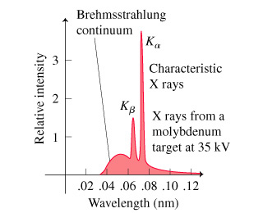
The radiation relative intensity graph shows a smooth curve of Bremsstrahlung or braking radiation corresponding to the range of energy losses due to collisions and peaks which are characteristics of the metal itself.
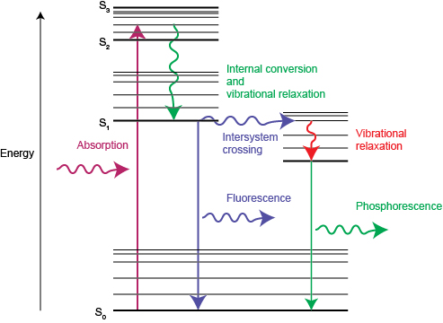

FLUORESCENCE AND PHOSPHORESCENCE
Fluorescence occurs when a non-visible light, usually ultraviolet, is absorbed by a substance and re-emitted in smaller, more energetic steps with wavelengths in the visible range. If there is a time delay between absorption and re-emission, the atom is said to be in a metastable state and the phenomenon is called phosphorescence. These substances glow in the dark.

BIG BANG THEORY: is the leading theory of how the universe began.
Evidence to support include;
- Universe is expanding, proven with red shift
- Cosmic microwave background radiation, energy which was created at the start, ongoing
- Abundance of ‘light elements’ (Hydrogen & Helium) found in observable universe
SPECIAL RELATIVITY
- Observations of objects travelling at very high speeds cannot be explained by Newtonian physics. These include the dilated half-life of high-speed muons created in the upper atmosphere, and the momentum of high-speed particles in particle accelerators
- Einstein’s special theory of relativity predicts significantly different results to those of Newtonian physics for velocities approaching the speed of light
- The special theory of relativity is based on two postulates: that the speed of light in a vacuum is an absolute constant and that all inertial reference frames are equivalent
- Motion can only be measured relative to an observer; length and time are relative quantities that depend on the observer’s frame of reference
Applies relationships $l=l_{0}√(1-\frac{v^{2}}{c^{2}})$ $t=\frac{t_{0}}{√(1-\frac{v^{2}}{c^{2}})}$ $u=\frac{v+u'}{1+\frac{vu'}{c^{2}}}$ $u^{'}=\frac{u-v}{1-\frac{uv}{c^{2}}}$
- Relativistic momentum increases at high relative speed and prevents an object from reaching the speed of light
Applies relationships $p_{v}=\frac{mv}{√(1-\frac{v^{2}}{c^{2}})}$
- The concept of mass-energy equivalence emerged from the special theory of relativity and explains the source of energy produced in nuclear reactions
Applies relationship $E=\frac{mc^{2}}{\sqrt{1}-\frac{v^{2}}{c^{2}}}$
The theory of special relativity is based on two postulates: the first of which reflects the absence of preferred frame of reference against which to develop the laws of physics. They are;
POSTULATE 1
All the laws of physics are the same in all inertial frames of reference
POSTULATE 2
The speed of light in a vacuum is the same in all inertial framed of reference
The reference against which the motion of an object is measured is called a frame of reference. An inertial frame of reference is one in which Newton’s first law of motion holds; 0 acceleration.
Einstein asserted that there is no “preferred” inertial frame of reference against which motion should be measured. In other words, all inertial frames of reference are equivalent. It does not matter which inertial frames of reference is used to judge the motion of an object. A person in a car moving at constant velocity v can have a velocity of 0 m s⁻¹ using the car as a frame of reference or v m s⁻¹ in the road’s frame of reference. However, the second postulate states that the speed of light is constant in all frames of reference which means light emitted from a moving source doesn’t travel faster than c in any other frame of reference.

TIME DILATION
Consider a clock that is assumed to consist of a source of light that fires a light pulse up to a mirror, which then reflects the light back down to the source, where it can be detected. Each ‘tick’ of this clock consists of the up and down motion of the light pulse.
Let us assume that two such identical ‘light pulse’ clocks are present in frames A and B with B moving in relation to A. let us first of all consider our observer in frame B, and how that observer sees the frame B clock functioning. The observer sees the light pulse travelling vertically upwards and then back down again after being reflected. The following diagram demonstrates this.
mirror
To an observer in frame B, the clock ‘ticks’ each time light is reflected vertically from the mirror and arrives back at the detector.

L
source

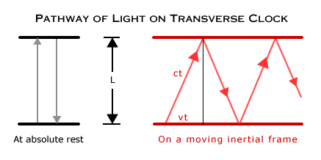
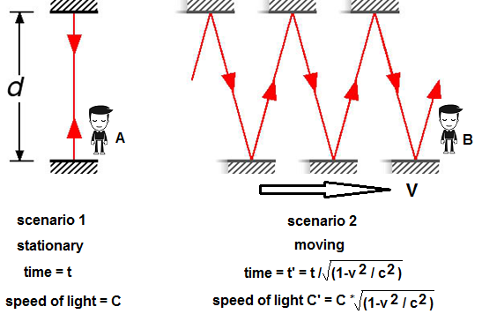

The crux of the time dilation effect is that the observer in frame A does NOT see the clock functioning in this way (remember, frame B is moving with respect to frame A). Instead, the observer in A would see the light following a diagonal path as frame B moves during a ‘tick’. Think about what we would see if the observer in B were to throw a ball vertically upwards, with respect to frame B. The following diagram shows why the observer in frame A would see the ball follow a diagonal path. Direction of travel
Throws ball… Ball reaches the top… Ball comes down…







To the observer in the car, the ball goes straight up and down, to the outside observer, the ball follows a zigzag path, as shown by the line.
The same argument applies to the light pulse on our simple clock, and each ‘tick’ of the clock in frame B appears, to an observer in frame A, as shown below.
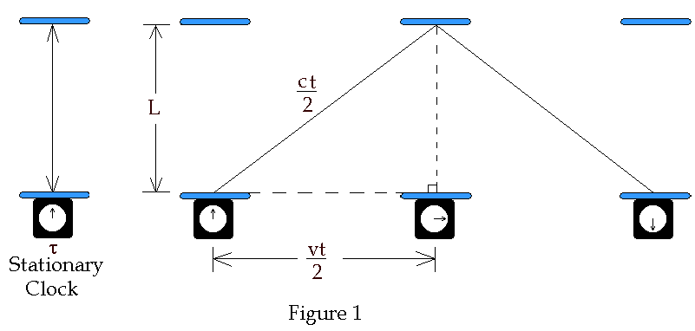
To an observer in Frame A, the light does not follow a vertical path. Instead, it follows the diagonal path as shown, and therefore appears to take a longer path from source to detector and back to the source.
The second postulate of relativity states that the speed of light is the same for all observers. However, to the observer in frame A, the path taken by the light pulse during each ‘tick’ of the clock is longer. Therefore, to the observer in frame A, the clock appears to tick more slowly than it does to the observer in frame B, because the light pulse has a longer path to follow.
A clock in a moving frame of reference (frame B) appears to tick more slowly than a clock in a stationary frame of reference (frame A).
The time required for a ‘tick’ to the observer in frame A is related to the time required for a ‘tick’ in frame B through the equation $T_{A}=\frac{T_{B}}{\sqrt{1}-\frac{v^{2}}{c^{2}}}$ where v is the velocity which frame B is moving, and c is the velocity of light. As v approaches c, $\frac{v^{2}}{c^{2}}$ approaches 1 and T_{A} approaches infinity.

LENGTH CONTRACTION
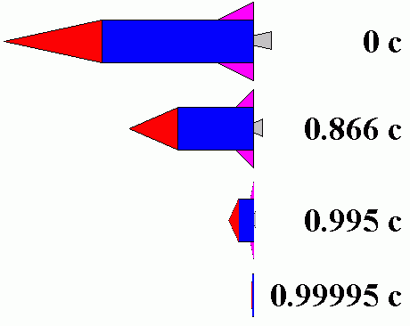
Both observers measure the speed of light as c (3 x 10⁸ m s⁻¹). $\frac{s}{t}$ in both frames of reference must equal c. As time slows down in the moving frames of reference, light travelling parallel to the direction of movement covers less distance from the stationary frame of reference’s perspective. This means length in the moving FOR contrasts according to the following equation
$$L=L_{0}\sqrt{1}-\frac{v^{2}}{c^{2}}$$
If we put various values of v into this equation, we can see that as v approaches c, L approaches 0.

SIMULTANEITY
Consider the following situation. A railway carriage moving close to c. one observer is inside, the other is outside. Two lights are turned on at the back and front of the carriage. What happens?
Now consider what observer B sees happen to observer A. She receives the light from right first, because she has moved towards that flash lamp, lessening the distance the light must travel and reducing the time it takes to get to her. Light travels at speed c relative to both observers, but observer B remains equidistant between the points where the flashes were emitted, while A gets closer to the emission point on the right. From observer B’s point of view, then, there is a time interval between the arrival of the flashes to observer A. Observe B measures the flashes to be simultaneous relative to him but not relative to A. Here a relative velocity between observers affects whether two events are observed to be simultaneous. Simultaneity is not absolute.



moving train observer A

v


observer B moving train observer A



v


observer B

Consider space time graphs with time on the y-axis and space (location) on the x-axis.




B clock
rocket moon
d
A light ray is emitted from a position a on earth at time t (A). It is transmitted to the relatively stationary mirror (B) on the moon and reflected back to (A). This scenario was described and defined as an inertial reference frame, which it is not. The time t for such total transmission was twice the distance d divided by c where $t=\frac{2d}{c}$. Thus the time of the reflection at position B was $t+\frac{t}{2}$. After t occurs, the light ray is received at position A.

light ray

A
earth clock
RELAVISTIC VELOCITY ADDITION
The Einstein velocity relationship transforms a measured velocity as seen in one inertial frame of reference (u) to the velocity as measured in a frame moving at velocity v with respect to it (u’). In problems involving more than two objects, the main difficulty is the assignment of velocity to all the objects.

A B v u’

“rest” observer “moving” observer projectile fired by B
u = velocity of projectile as seen by A u’ = velocity of projectile as seen by B
If A sees B moving at velocity v, then a velocity measured by B (u’) would be seen by A as
$u=\frac{v+u'}{1+\frac{vu'}{c^{2}}}$ and the reverse transformation being $u^{'}=\frac{u-v}{1-\frac{uv}{c^{2}}}$

Example; if spaceship A moving at 0.6c approaches spaceship B which is moving at 0.8c, what is B’s velocity as seen by A?

A B
v_{A} v_{B}

common sense suggests an approach speed = |v_{A}| + |v_{B}|
to apply the relativistic velocity relationship, we must identify the appropriate velocity to associate with each symbol $u^{'}=\frac{u-v}{1-\frac{uv}{c^{2}}}$
let v_{B} be the velocity as seen by the external reference frame v_{B} = u
then v_{A} is the speed of the secondary reference frame v_{A} = v
then u’ is the speed of B as seen by A (the relative velocity) $u^{'}=\frac{v_{B}-v_{A}}{1-\frac{v_{B}v_{A}}{c^{2}}}$
$$u^{'}=\frac{u-v}{1-\frac{uv}{c^{2}}}=0.385c$$

THE STANDARD MODEL
A neutrino is a very small piece of matter. It’s so small that it wasn’t even discovered until 1956. There are three ‘flavours’ of neutrinos: electron, muon and tau. Most people are familiar with three particles of matter: electron, neutron and proton.
Proton and neutrons fall into a category of particles called fermionic hadrons or baryons. Fermions in general are the building blocks of matter. Baryons are made up of quarks and there are six types of quarks resulting in about 120 baryons.
Neutrinos however fall into a category called leptons. Leptons are also fermions and together with quarks make up matter. The difference between leptons and quarks, is that leptons exist on their own, where quarks combine to form baryons. There are 6 types of leptons: electron, electron neutrino, muon, muon neutrino, tau and tau neutrino. For each of these, the neutrino brand carries a neutral charge, while their counterparts all have a negative charge. NOTE: there is NO CORRELATION between the particles in the same rows, it’s just how the table is lined up.
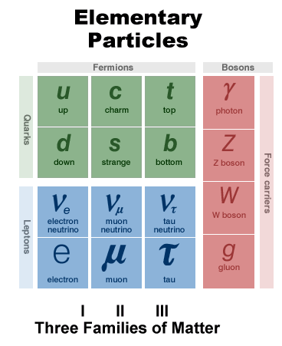
Fermions
Leptons  Name Charge  Electron Neutrino 0  Electron -1  Muon Neutrino 0  Muon -1  Tau Neutrino 0  Tau -1 | Quarks  Name Charge  Up 2/3  Down -1/3  Charm 2/3  Strange -1/3  Top 2/3  Bottom -1/3

Now there is another class of particles called Bosons. They are also made up of quarks, like fermions. The property that separates bosons from fermions is called spin. If it has an integer spin, it is a boson. If it has a spin +- 1/2, +- 3/2 then it is a fermion. Another class of particles is known as mesons which are also bosons. One example of a meson that will come up later is the pion. While fermions are the matter particles, it would be convenient to think of bosons as the mediators of force: where the gluons mediate strong force, photons W+, W- and Z particles mediate electroweak force, and the as yet unobserved graviton mediates the gravitational force. Mesons are also bosons since they too are made of quarks, with integer spins.
This is a very basic description of what is known as the Standard Model of Fundamental Particles. But it is also important to know that there are several forces that act upon particles: gravitational, weak, strong and electromagnetic. Each type of particle interacts differently to each force. For example, every particle with mass interacts gravitationally, but only electrically charged particles interact electromagnetically. Quarks and gluons interact via the strong force, and quarks and leptons interact via the weak force.

PARTICLE INTERACTIONS AND CONSERVATIVE LAWS
- In developing the standard model for particles, certain types of interactions and decays are observed to be allowed and others seem to be forbidden
- The study of interactions has led to a number of conservative laws which govern them
- These conservative laws are in addition to the classical conservation laws such as conservation of energy, charge etc., which still apply in the realm of particle interactions
- Strong overall conservative laws are the conservation of baryon number and the conservation of lepton number. Specific quantum numbers have been assigned to the different fundamental particles, and other conservative laws are associated with those quantum numbers.
- Every process that is not forbidden must occur
- To calculate the Baryon number use the following equation $B=\frac{1}{3}(n_{q}-n_{aq})$
So Baryons have a +1 number and Mesons have a 0 number.
For example, a proton combining with a neutron to form a proton and a muon and anti-muon is forbidden
$$p+n⟶p+μ^{+}+μ^{-}$$
$$B=1+1 ≠1+ 0+0$$

Conservation of Lepton number also applies.
eg. The decay of a neutron.
$$n ⦳ p^{+}+e^{-}$$
$$n ⟶p^{+}+e^{-}+ṽ_{e}$$

The lepton number on the left is 0, but on the right is +1. So in order to balance the lepton number, an electron neutrino anti particle is added.

